APP UPDATE: Full app completed. Officer can login and see assigned inspections to her/him. Segregated in pending and completed. Can start and complete an inspection fully.

WEB UPDATE: IPFS DONE FULLY. Uploaded photos going to ipfs via flutter app and cids fetched and from ipfs and each photos cid stored in json payload and in db.

App login and landing pages
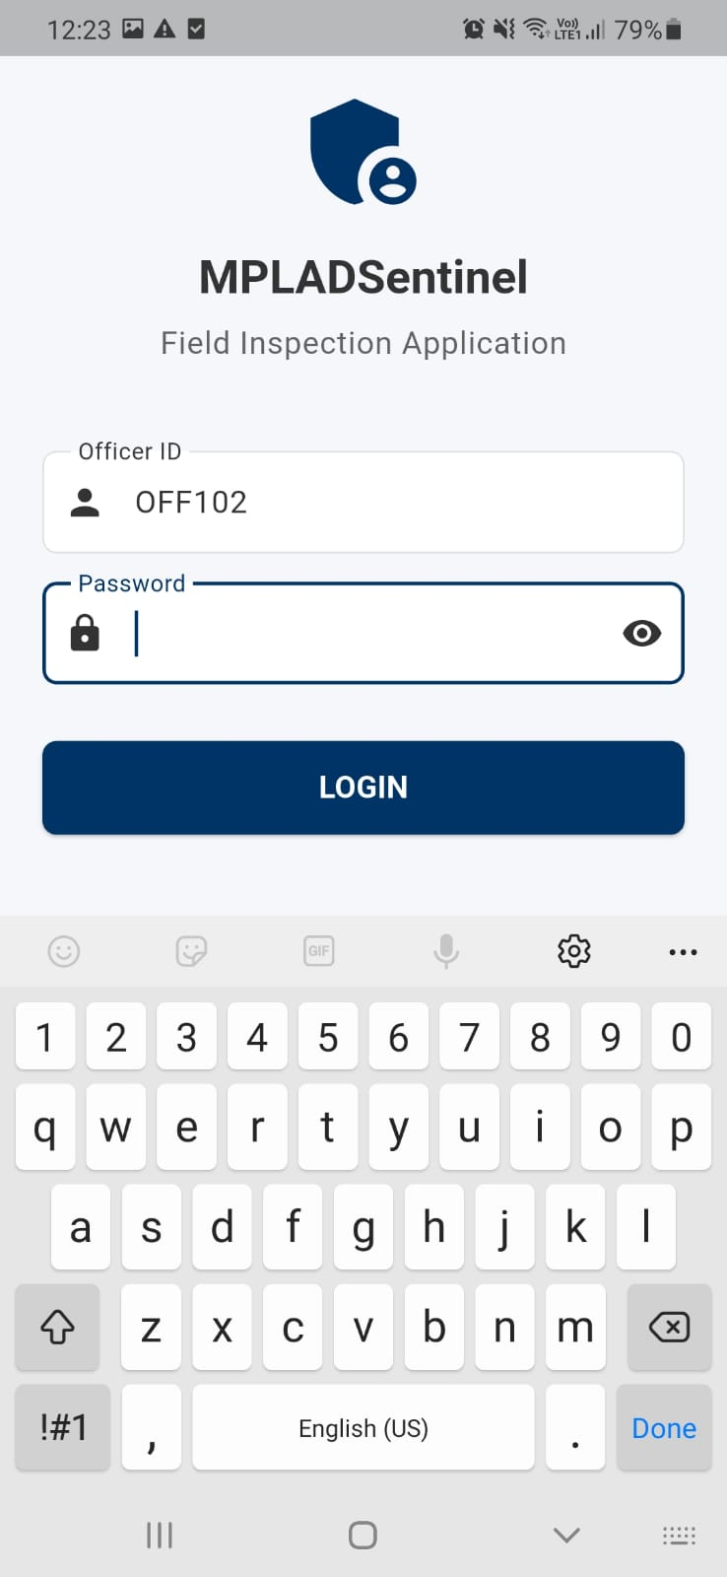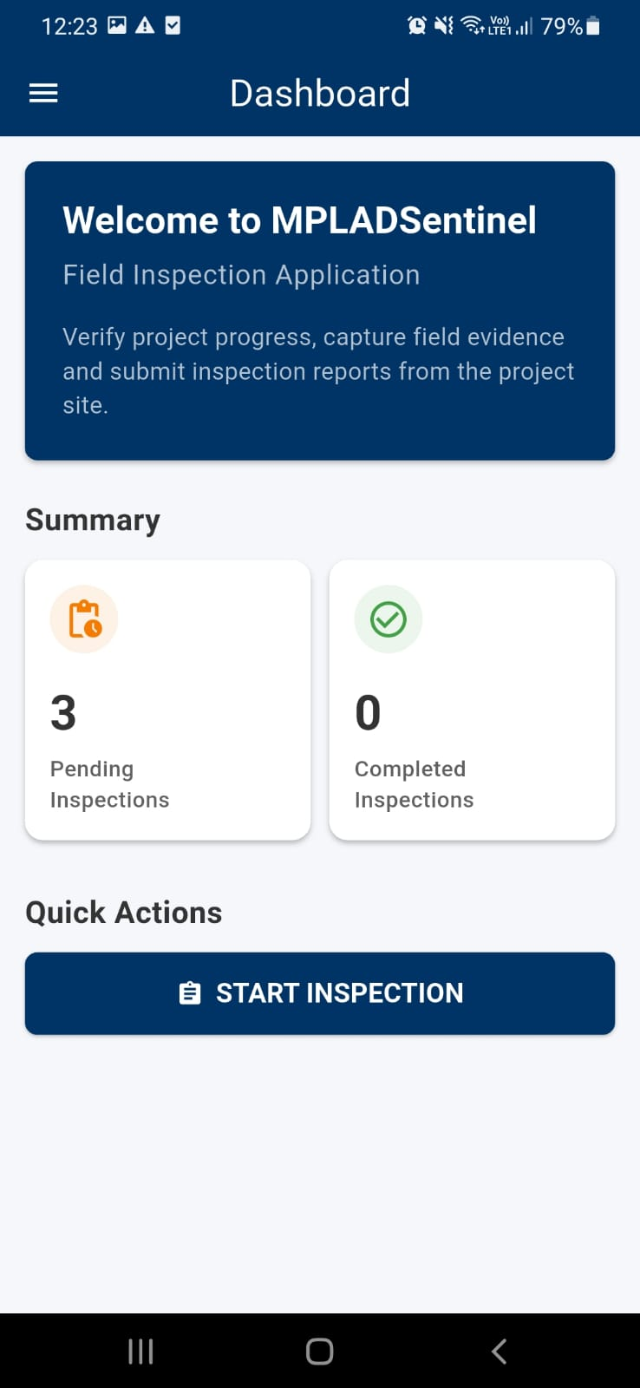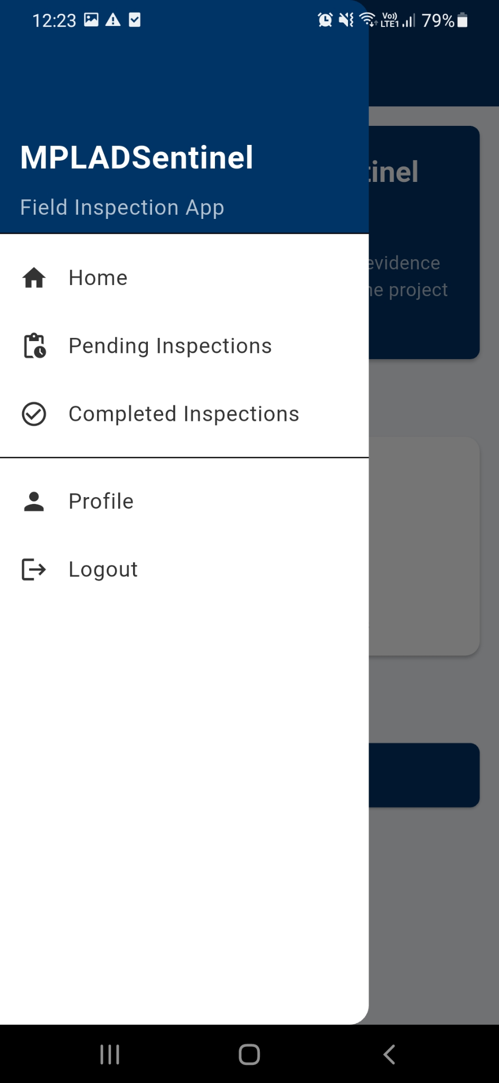

Pending inspections shows the pending ones assigned to the officer logged in. Then once an inspection is decided to start, form opens.
Photos to be captured by in app camera only. Not allowed to upload via gallery.
Each photo is geotagged and embedded with location, timestamp and exif format then uploaded to IPFS PINATA CLOUD then its cid from pinata if fetched and stored. We can also fetch the photo from pinata and verify exif metadata.
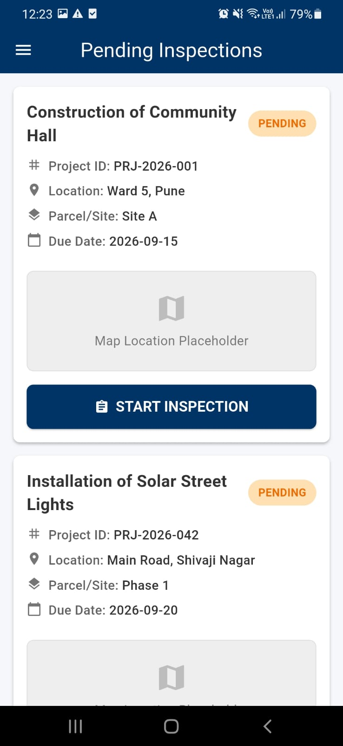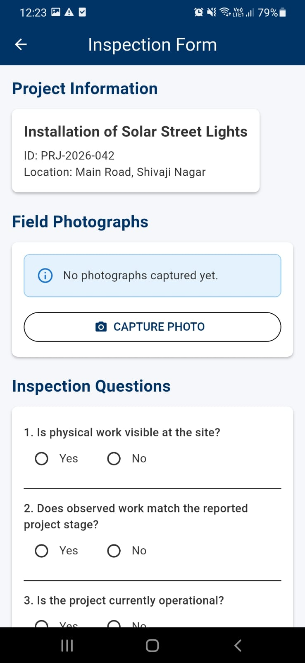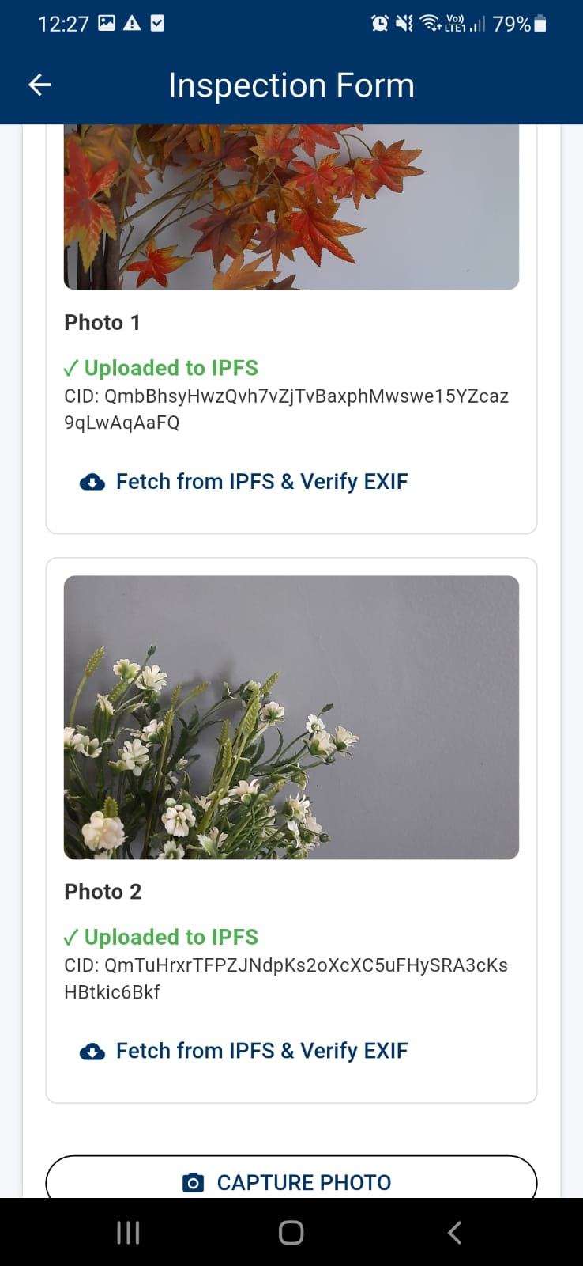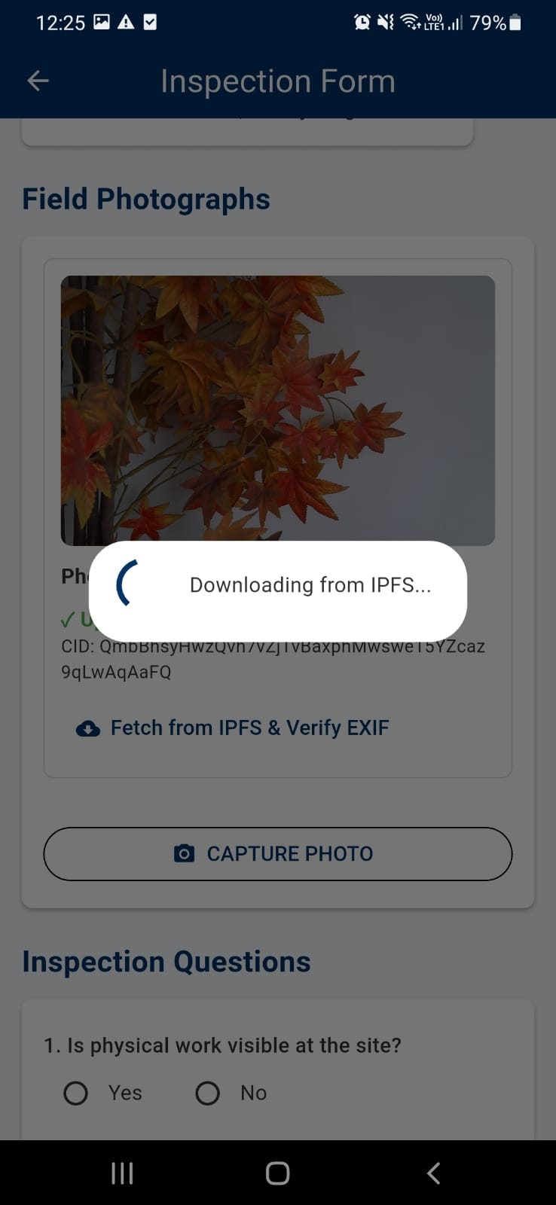

Then fill form with project status and remarks. Then while submission, officer name, id, location, time is auto fetched. And submitted to sign off the submission. Whole submission except for photos of ipfs but their cids are stored in db of app and also a json payload of it all is stored for future integration/sending to portal website. Then the inspection is marked completed and moved to completed section from pending.

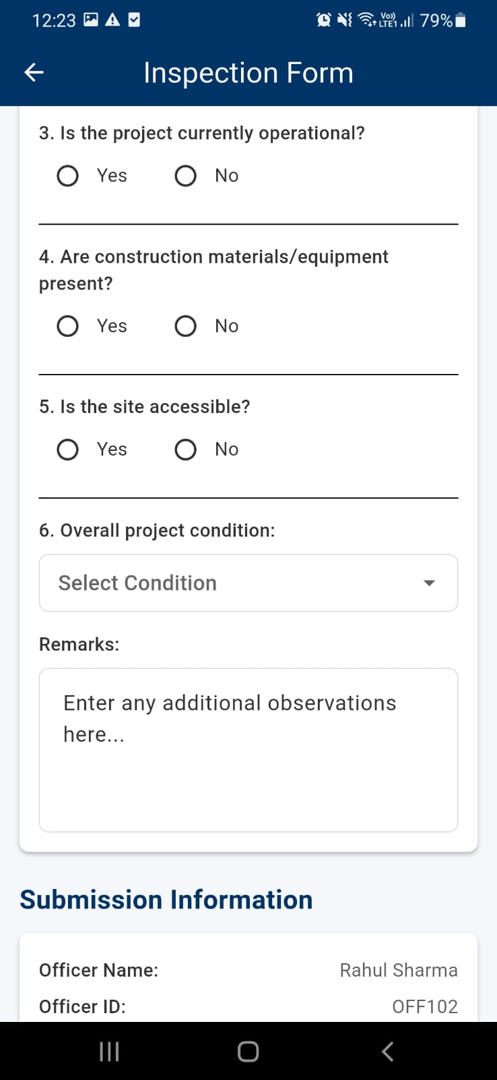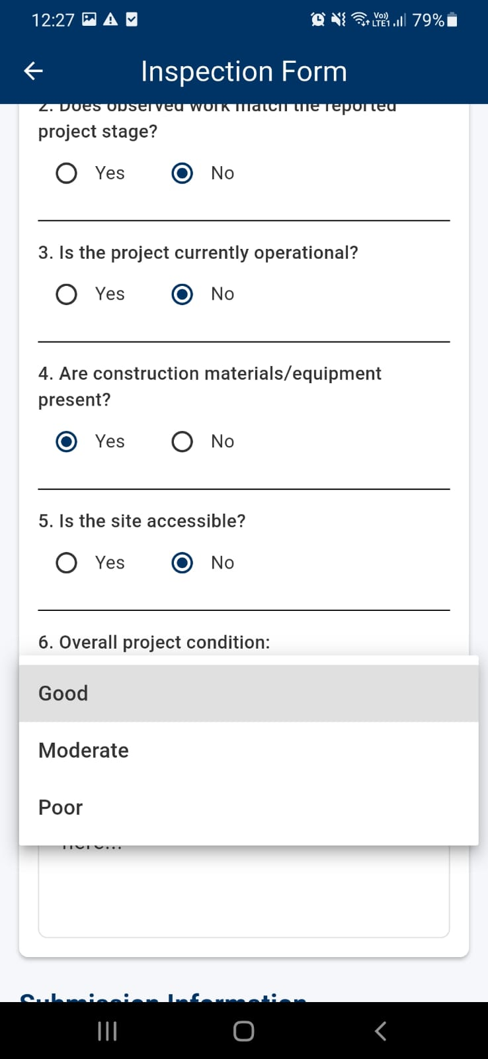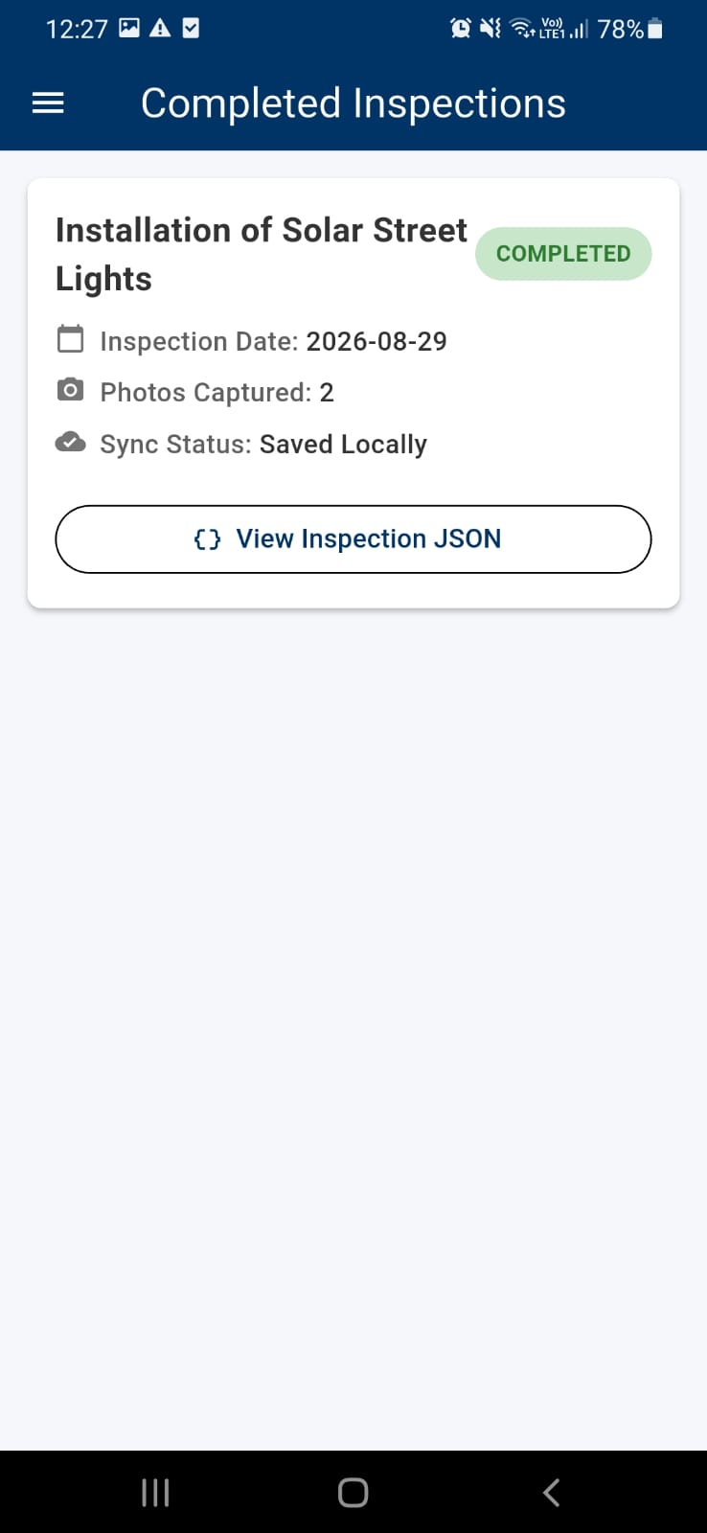
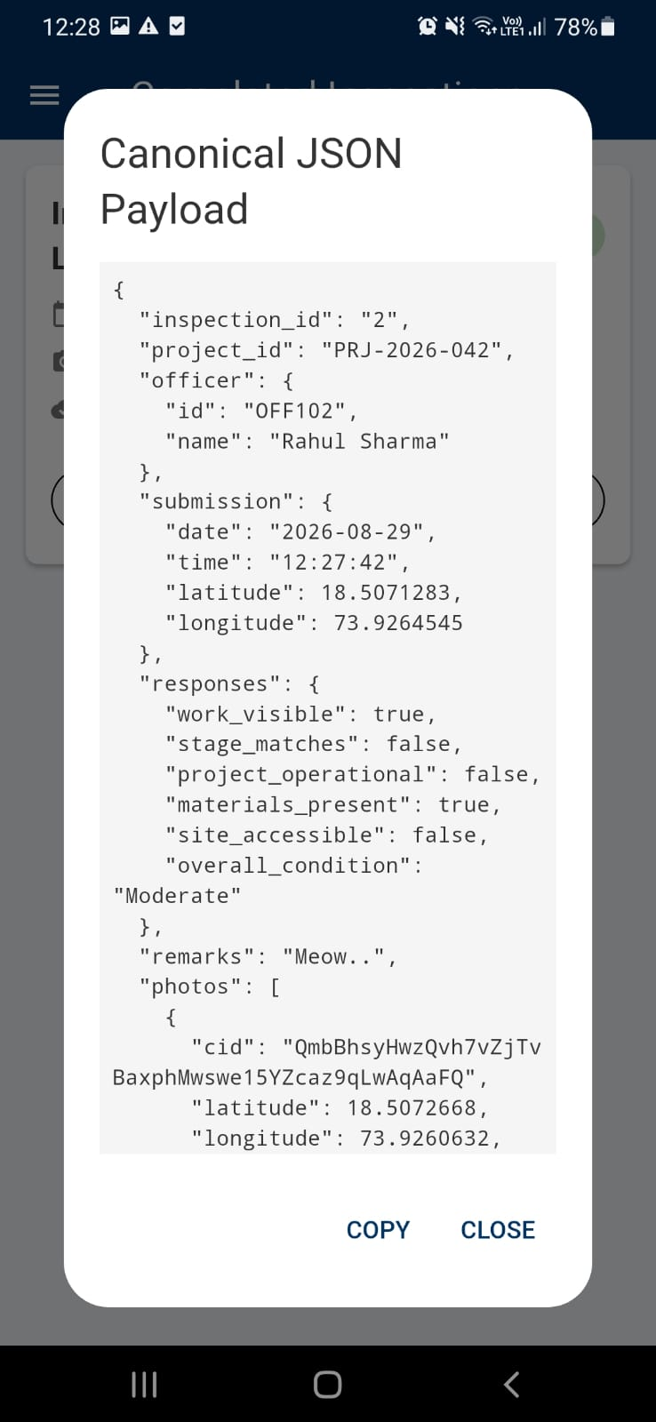

Can see on ipfs that all images have occurred with proper naming. Naming contains MPLAD projname officerid date time —FORMAT. Cids are also onipfs if tampered or edited, cid will change on ipfs and not match the cid in app db json and portal db. EVIDENCE OF TAMPERMENT.
